DEEPAK SAINI

19BEC1113

ECE-2

EXP: **Design a system for gift box such that whenever it is opened, it produces sound for 1000ms and blinks red green LEDs alternatively, as long as it is open.**

CIRCUIT DIAGRAM:

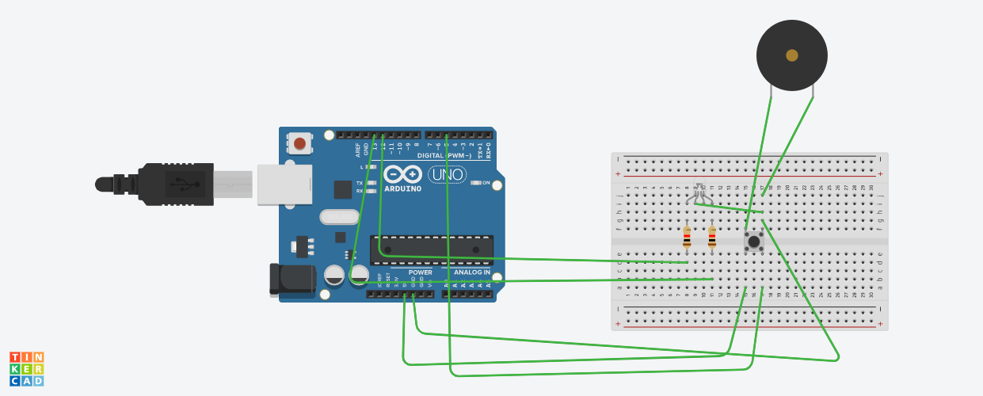

THEORY

CONCEPT USED: Concept of working of arduino, LED, resistor, switch, piezo and breadboard.

LEARNING AND OBERVATION: We can monitor opening of a gift.

PROBLEMS: LEDs were on blinking alternatively.

TROUBLESHOOTING: Code made correct by using correct if-else loop.

PRECAUIONS: Use resistors in connecting LEDs anode to arduino’s digital terminals also check connections of switch.

LEARNING OUTCOMES: Learned how to make a project with Arduino and using other components.

CODE:

int led1 = 13;

int led2 = 12;

int i=0;

int switchpin=5;

int a;

void setup() {

Serial.begin(9600);

pinMode(led1, OUTPUT);

pinMode(led2, OUTPUT);

pinMode(5,INPUT);

}

void loop()

{

a=digitalRead(5);

if(a==LOW)

{

digitalWrite(led1, HIGH);

delay(1000);

digitalWrite(led1, LOW);

delay(1000);

digitalWrite(led2, HIGH);

delay(1000);

digitalWrite(led2, LOW);

delay(1000);

}

else

{

digitalWrite(led1,LOW);

delay(1000);

digitalWrite(led2, LOW);

delay(1000);

}

}